**Date**: 9th February 2022

**Abraca-data**

**Weekly Report**

**Tasks performed in this week**

1. Finalized the dataset to work on: Initially, we had planned to use the UCI dataset. However, as we started to work on the topic, we came across a dataset that is comparatively more extensive than the previously selected one.
2. The dataset finalized was analyzed using python:
   1. Read the data file.
   2. Started with the data cleaning (Null values handling and duplicate values handling).
   3. Data visualization (using Box plots) and understanding the data representation through it.

-------------------------------------------------------------------------------------------------------------------

**Outcomes of the tasks performed**

1. Dataset reading and describing:

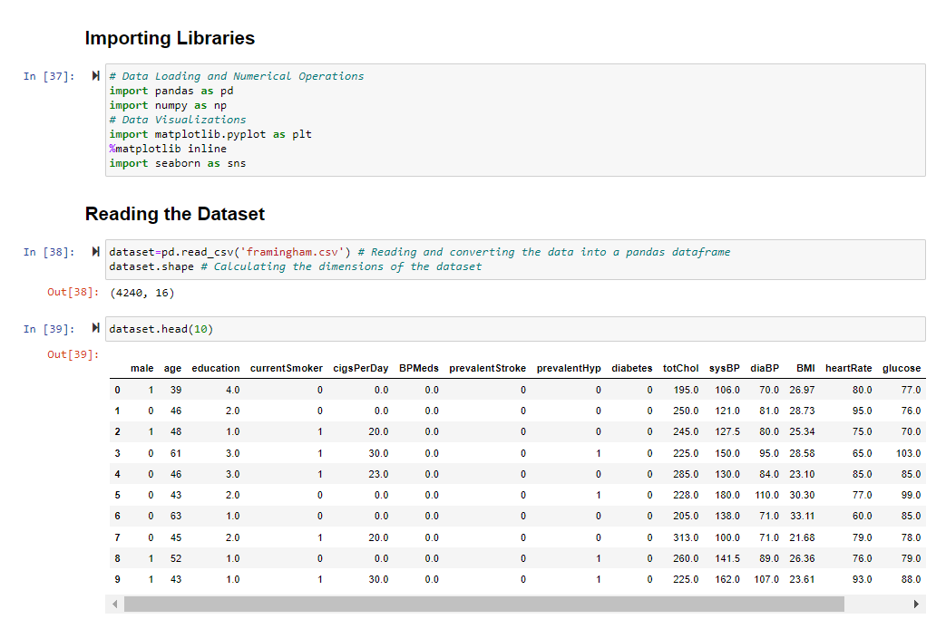

1. Finding Null and Duplicate values (Some null values were present, no duplicate values):

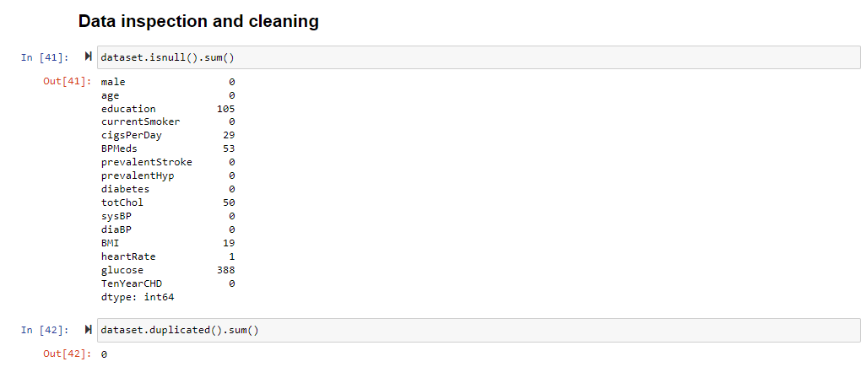

1. Null Values Handling:

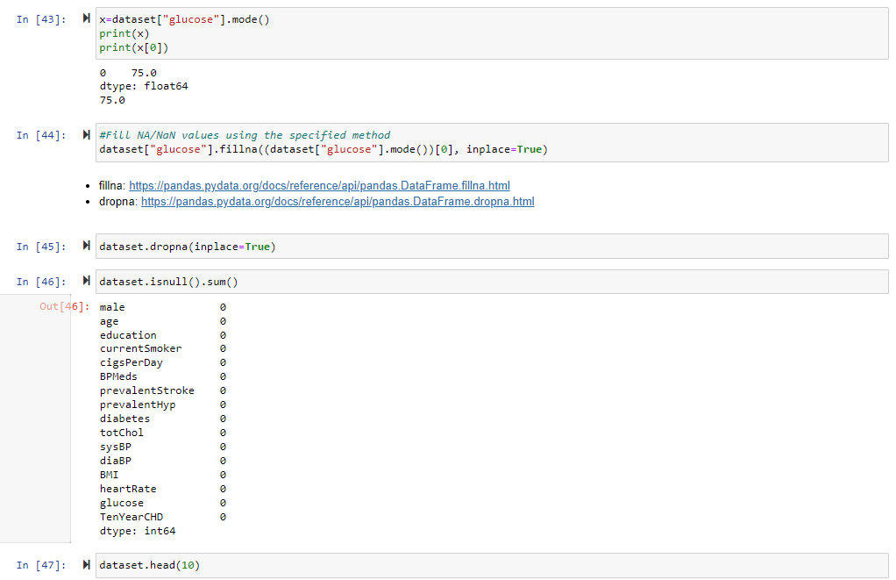

1. Visualization using Box-plot:

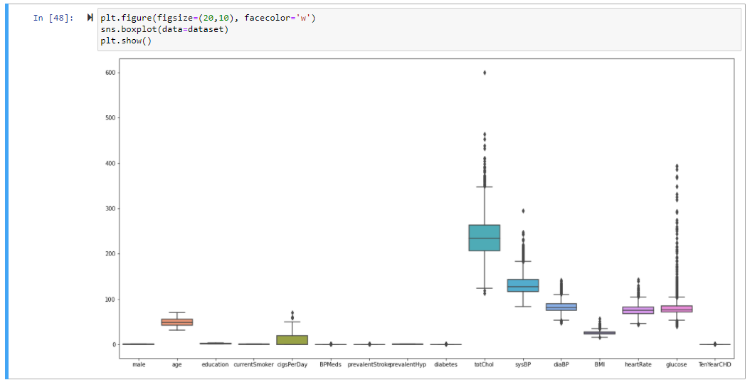

--------------------------------------------------------------------------------------------------------------------

**Tasks to be performed in the upcoming week**

1. Detect and handle outliers in the existing dataset
2. Start with Exploratory Data Analysis